Maths Department Exit Ticket

Topic: Expressions, Functions and Formulae (Core/Depth)

Q1.
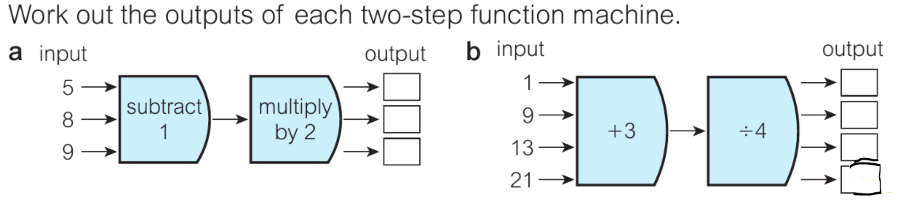
A. output = 8, 14, 16. B. output = 1, 3, 4, 6.
Q2.
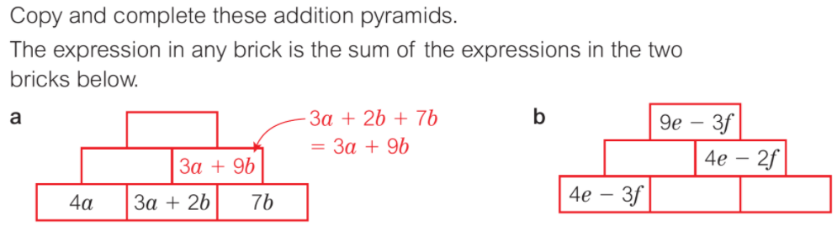
A = middle = 7a + 2b. top = 10a +11b. B = middle = 5e – f. bottom left = e – -2f. bottom right = 3e + 4f
Q3.
- 2(3x + 4) + 6(x + 2) b. 4(x – 3) + 7(2x – 1)
= 6x + 8 + 6(x + 2) = 4x – 12 + 7(2x – 1)
=6x + 8 + 6x + 12 = 4x – 12 + 14x - 7
=12x + 8 + 12 = 18x – 12 - 7
= 12x + 20 = 18x - 19
Q4.
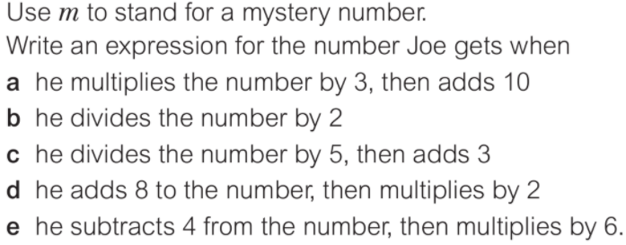
- 3m + 10. B. m / 2. C. m / 5 + 3. D.(m + 2)2 E.(m-4)6

Q5.

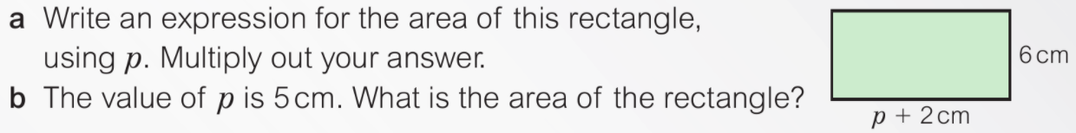
- 6p + 12 b. 42cm
Q6.
X = p – 5

S: I can _____________________________

_______________________________________

T: To be able to ______________________

_______________________________________

