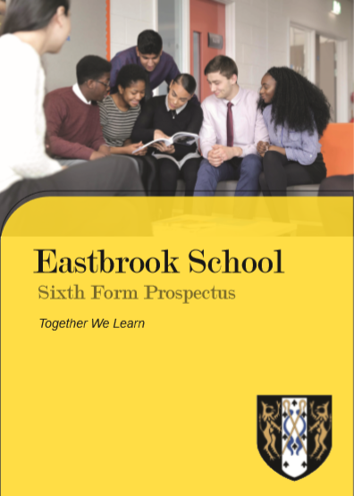

Dear Parent and Future Eastbrook 6th form Student
Let me summarise some of the reasons why I think coming to Eastbrook is a very good idea.
Our teachers are totally committed to ensuring that every student achieves at the highest possible level – as long as you work hard you will do very well.
Pastoral care is central to what we do – sometimes the 6th form can sometimes be tough but all students will get the support and guidance they need to be successful
Everyone is an individual – we will take the time to get know you and build your 6th form experience around your needs and interests
We will help you to achieve your goals and ambitions – through our personalised career guidance every Year 13 student last year went on to the career path of their choice
We have brand new, state of the art buildings and facilities – it would be hard to find a better environment to learn and develop as a young adult
You are regarded and treated as an adult – I want the 6th form to feel like a stepping stone to university so you will be trusted, given a lot of independence and able to access to a range of 6th form privileges.
We belong to a 6th form consortium with Robert Clack and All Saints – between us it is highly likely that we will be able to provide you with the subjects you want to study.

Yours faithfully
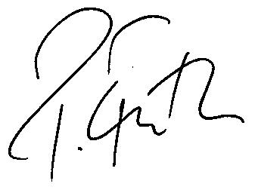
Paul Frith
Headteacher

Why choose Eastbrook?

We achieve excellent results

- A Level results 92% pass rate
- Vocational average grade Merit/Distinction

Our students are guided and supported into University or Apprenticeships and Employment at the end of their studies.

Every student that applied to University got a place on courses such as:
Law, Psychology, Social care, Biology, Forensic Science, Drama, Film Studies, Criminology, Digital media, Zoology, Business.

Most of our more able students moving towards more academic pathways with applications to Medicine and Dentistry this year.

We have a dedicated Sixth form study centre with ICT suite and kitchen area.

Bursary paid to the top students that stay on at Eastbrook!

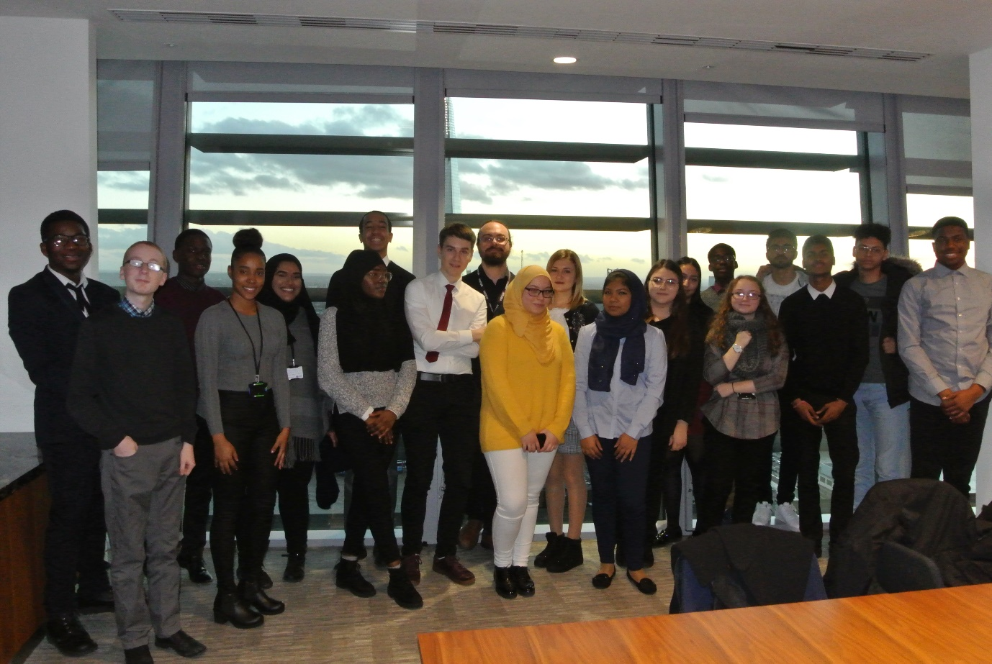

Enrichment activities
- University trips and UCAS support
- Academic mentoring from top London Companies and Universities
- Summer schools and aim higher talks
- Work Experience and management training
- Sixth Form Council
- Opportunities to volunteer and work with younger pupils in our school
- Trips within subjects including galleries, legal and insurance firms and Finance institutions
- Cinema and theatre trips
- Targeted experiences for law and medical applicants
- Outside speakers to present Apprenticeship opportunities
We regularly consult our students about their 6th form experience and our students say:

“We have excellent teachers that really know their subjects. I am making great progress”

“The work I do is interesting and relevant to the real world. I am really enjoying the 6th form

“You have more freedom and are treated like an adult”

“You feel supported”

“All the work set in relevant and worthwhile”
“There are different places to study like the silent study room or the IT room”
“I have made some great new friends!”

“The facilities to study are amazing… I can focus

In Jan 2018 Ofsted said:
“The majority of students continue their studies to the end of Year 13. Careers information and guidance are strong and lead to an increasing number of students entering higher education, including some of the top-performing universities”.
They judged our Sixth Form to be ‘Good.’
Entry requirements
A levels

You will need 5 separate subjects passed at 4 grade or above. These subjects will ideally include English (Language or literature) and Maths at grade 5 or above.

A Level Subjects | English | Maths | GCSE APS | Previous  Study? | Comment
Art | 5 | 5 | 4 | Yes | Good practical skills needed, and the ability to research and work independently. See subject leader if English grade not achieved.
Biology | 6 | 6 | 5.5 | Yes | Students must have taken higher papers in double or triple science and achieved grade 6 or above
Business Studies | 6 | 5 | 4.5 | No | Should not be studied alongside A Level Economics.
Chemistry | 5 | 6 | 5.5 | Yes | Students must have taken higher papers in double or triple science and achieved grade 6 or above
Computer Science | 6 | 6 | 5.5 | No
Design and Technology | 5 | 5 | 5 | Yes | You must achieve at least a 6 in D and T at GCSE
Drama and Theatre Studies | 5 | 5 | 4 | No | Other performance related subjects considered if no GCSE drama.
Economics | 6 | 6 | 5.5 | No | Should not be studied alongside Business Studies A Level.
English Literature | 6 | 5 | 43 | Yes | Students must have taken the Higher paper and obtained a 6 in English Literature.
Film Studies | 5 | 5 | 4 | No
French | 6 | 5 | 4.5 | Yes | You must achieve at least a grade 7 in GCSE French.
Geography | 6 | 5 | 4.5 | No | If studied at GCSE a 5 is required. However, it is possible to study Geography without having done GCSE
Graphics | 5 | 5 | 4 | Yes | You must achieve a 6 in an Art related subject.
History | 6 | 5 | 4.5 | Yes | You must have achieved at least a 6 in History at GCSE
Law | 6 | 6 | 4.5 | No
Mathematics | 5 | 7 | 5.5 | Yes | You must achieve at least a 7 in Maths
Media | 5 | 5 | 4 | No | At least a 5 in English Literature is required
Music | 6 | 5 | 5.5 | Yes | Must have studied at GCSE and achieved a 7 grade. Must be at least a grade 5 on instrument or voice
Philosophy & Ethics | 6 | 5 | 4.5 | No | 6 required in a Humanities subject, if grades not achieved refer to subject teacher for case by case assessment
Photography | 5 | 5 | 4 | No | Interview required with Art department to determine suitability if no 5 in an Art related subject
Politics | 6 | 5 | 4.5 | No | A further 5 in a humanities subject is also preferred.
Physics | 5 | 6 | 5.5 | Yes | 7 in Maths preferred, 6 acceptable if proven track record of hard work.
Psychology | 6 | 6 | 5.5 | No
Sociology | 6 | 5 | 4.5 | No | A grade 6 in English Literature or a 6 in essay based subject is desirable.
Spanish | 6 | 5 | 4.5 | Yes | Must achieve at least a grade 7 in GCSE Spanish.
Sport | 5 | 5 | 4 | No

Vocational

You will need to have achieved at least a grade 4 in 4 separate subjects at GCSE. These subjects will ideally include English (Language or literature) and Maths at grade 4 or above.

Vocational Subjects | English | Maths | GCSE  APS  needed | Previous  Study  Needed? | Comment
Business Studies | 4 | 4 | 3.5 | No | Previous study is an advantage you don’t have grade in English.
Dance | 4 | 4 | 3.5 | No | A genuine interest in Dance and an aptitude for the subject. Previous Dance experience needed. Very practical subject - not suitable if you have a long term injury.
Engineering | 5 | 5 | 4 | No | Previous study considered if you don’t have a grade 5 in English or Maths.
Food and Nutrition | 4 | 4 | 3.5 | No | An interest Food and catering required.
ICT | 4 | 4 | 3.5 | Yes | Previous study considered if you don’t have grade 4 in English or Maths.
Media | 4 | 4 | 3.5 | No
Performing Arts | 4 | 4 | 4 | Ideally | An interest in and commitment to Performing Arts.
Science | 5 | 5 | 4 | Yes | Previous study required if you don’t have a grade 5 in English or Maths.
Sport | 4 | 4 | 3.5 | No | 4 in Science preferred. Previous study considered if you don’t have grade 4 in English or Maths.

Full time vocational courses
Full Time Vocational Courses | English | Maths | GCSE  APS | Previous study | Comment
Beauty (Level 2) | 3 | 3 | N/A | No | Separate interview required with Head of Beauty. 1 year course. Gives access to Level 3 course in Year 13.
Business and ICT (Level 3) | 3 | 3 | N/A | No | 2 year course
Child Care (CACHE, Level 3) | 4 | 4 | N/A | No

 |  | Provisional Subject Blocking 2020 - 21
Block 1 |  | Block 2 |  | Block 3 |  | Block 4
Eastbrook
Economics (A Level) |  | Business (Voc) |  | Film (A Level) |  | Sociology (A Level)
Photography (Voc) |  | English Lit (A Level) |  | ICT (Voc) |  | Applied Science (Voc)
Sport (Voc) |  | Maths (A Level)
Child Development Cache (Voc) - Full time course
Robert Clack
ICT Double (Voc) |  | Media (Voc) |  | Business Single (Voc) |  | ICT Double (Voc)
ICT Single (Voc) |  | Sport (Voc) |  | Business Double (Voc) |  | Business Double (Voc)
Dance (Voc) |  | Art (A Level) |  | Food & Nutrition Sci (Voc) |  | Media (Voc)
Media (Voc) |  | Engineering (Voc) |  | Drama (A Level) |  | ICT (Voc)
Photography (A Level) |  | English Lit (A Level) |  | Film (A Level) |  | Science (Voc)
English Lang (A Level) |  | Sociology (A Level) |  | Geography (A Level) |  | History (A Level)
History (A Level) |  | Maths (A Level) |  | Philosophy & Ethics (A Level) |  | Philosophy & Ethics (A Level)
Biology (A Level) |  | Maths (+further) (A Level) |  | Maths (A Level) |  | French (A Level)
Economics (A Level) |  |  |  | Further Maths (A Level) |  | Chemistry (RC)
Physics (A Level) |  |  |  | Biology (A Level) |  | Music (A Level)
 |  |  |  | Computer Science (A Level)
 |  |  |  | Psychology (A Level)
All Saints
Art (A Level) |  | English Lit (A Level) |  | Biology (A Level) |  | Chemistry (A Level)
Business (Voc) |  | Government & Politics (A Level) |  | Economics (A Level) |  | Computer Science (A Level)
Business (A Level) |  | Mathematics (A Level) |  | English Lit (A Level) |  | History (A Level)
Physics (A Level) |  | Media (A Level) |  | Geography (A Level) |  | Law (A Level)
Psychology (A Level) |  | Philosophy & Ethics (A Level) |  | Graphics – Art (A Level) |  | Performing Arts (Voc)
Sport (Voc) |  | Health and Social Care (Voc) |  | ICT single (Voc) |  | Sociology (A Level)
Design and Technology(A Level) |  |  |  | Science (Voc)

