Task 1 The Boy who cried Wolf
Once upon a time, there lived a shepherd boy who was bored watching his flock of sheep on the hill. To amuse himself, he shouted, “Wolf! Wolf! The sheep are being chased by the wolf!” The villagers came running to help the boy and save the sheep. They found nothing and the boy just laughed looking at their angry faces.
“Don’t cry ‘wolf’ when there’s no wolf boy!”, they said angrily and left. The boy just laughed at them.
After a while, he got bored and cried ‘wolf!’ again, fooling the villagers a second time. The angry villagers warned the boy a second time and left. The boy continued watching the flock. After a while, he saw a real wolf and cried loudly, “Wolf! Please help! The wolf is chasing the sheep. Help!”
But this time, no one turned up to help. By evening, when the boy didn’t return home, the villagers wondered what happened to him and went up the hill. The boy sat on the hill weeping. “Why didn’t you come when I called out that there was a wolf?” he asked angrily. “The flock is scattered now”, he said.
An old villager approached him and said, “People won’t believe liars even when they tell the truth. We’ll look for your sheep tomorrow morning. Let’s go home now”.
Create six picture to tell the story of the boy who cried wolf and then put a caption to describe each picture. Add colour to your story board.

Task 2

You are to create a Drama poster for the drama department

Task 3 Look at this script and write an ending for this script.
Play script: I Spy
Cast: Mum, Dad, David and Megan.
Scene 1
(The family is in the car on the way to the sea-side)
David: (Whining) Dad, are we nearly there yet?
Megan: (Shoves David) I'm getting fed up with you!
Dad: (Angrily) Look, it’s bad enough driving for two hours without having to listen to you two arguing.
Mum: (Snappily) Be quiet you to, find something to do with yourselves.
Megan: (Whining) But mum, I’ve read all my comics and done all my puzzles.
David: I've read my comic too (whines) AND I've listened to my story tapes.
Mum: O.K. then, let's play I Spy for a while, you start, Megan.
Megan: (Looks at David) I spy with my little eye something beginning with F.
Scene 2
(Everyone looks tired)
David: I give up, it’s too hard, what do you spy beginning with F?
Megan: (Pointing at David) F is for FOOL!
Mum: (Frowning at Megan) Megan, that’s nasty, apologise at once.
Megan: (Quietly) Sorry. Your go.
(A pause while David thinks, he looks very confused)
David: I spy with my little eye something beginning with G.

Now finish the script of what you think happened on the road trip.

Scene 3

STYLES OF THEATRE
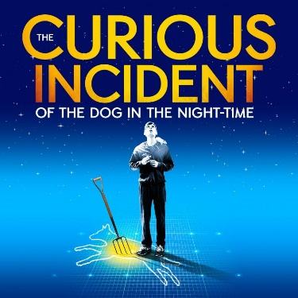
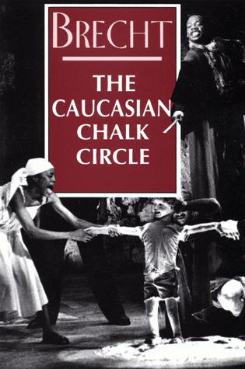
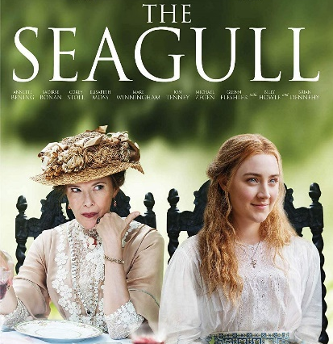
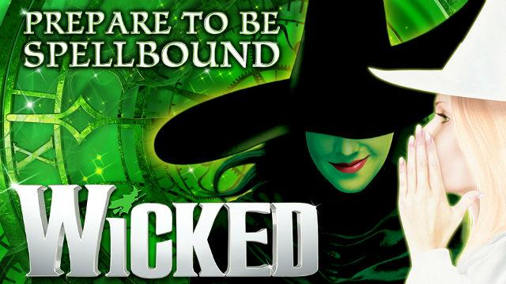
TASK 4: You need to link the performance to the style of theatre in which they are a part of. You will need to research the performances to find out what they are about and which style they are. The first one has been done for you.
NATURLAISM
EPIC THEATRE
MUSICAL THEATRE
MELODRAMA
PHYSICAL THEATRE

