LINE DRAWING MADE EASY
SIMPLIFYING OBJECTS USING GEOMETRIC SHAPES – LINE DRAWING.
COPY THE EXAMPLE THEN TRY ONE OF YOUR OWN IT CAN BE ANY OBJECT .
DRAW FROM WHAT YOU SEE AND NOT FROM MEMORY.

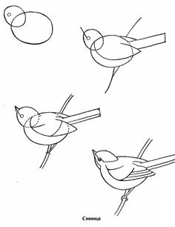

TONE.
UNDERSTANDING HOW TO USE TONE - SHADING TO CREATE A SENSE OF SOLIDITY.
THE ILLUSIONOF 3D.
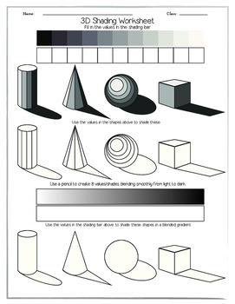

CREATING SURFACE PATTERN THROUGH MARK MAKING
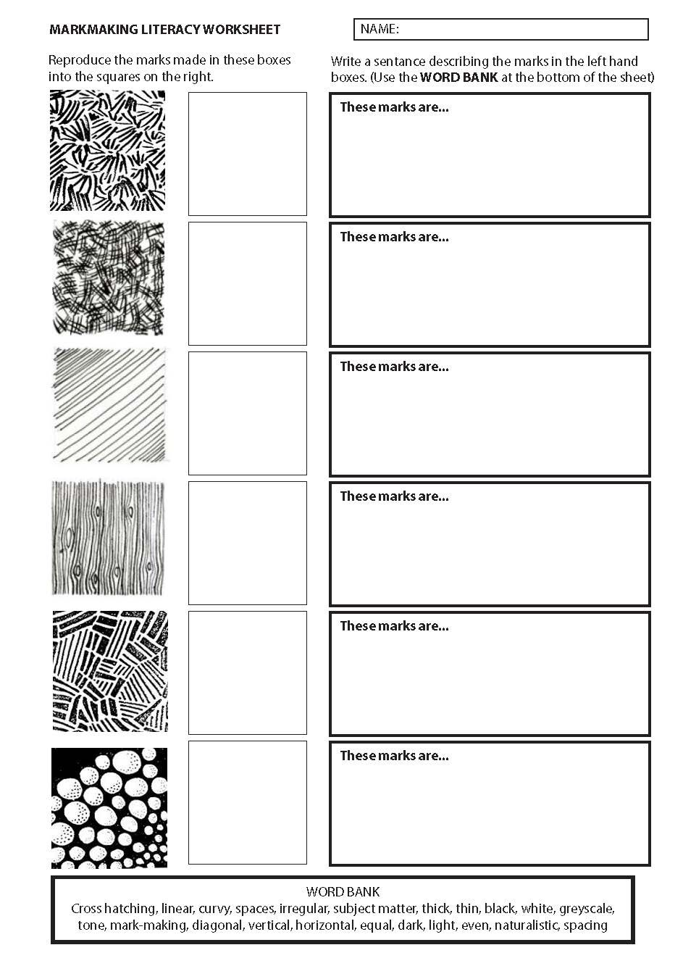
PATTERNS ARE CREATED WHEN SHAPES ARE REPEATED.
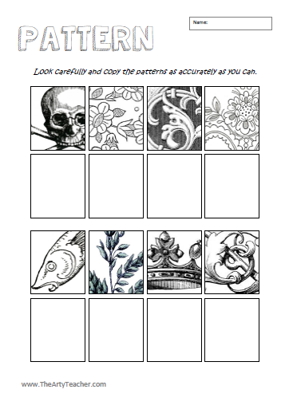
HOT/ WARM AND COLD/COOL COLOURS.
CREATE A PATTERN USING DIFFERENT LINES FOR EXAMPLE. STRAIGHT, WAVY, ZIGZAG, CURVY, HORIZONTAL, VERTICAL AND DIAGONAL.
ADD COLOUR AND MEDIUM . DECIDE WHICH AREAS SHOULD BE WARM OR COLD
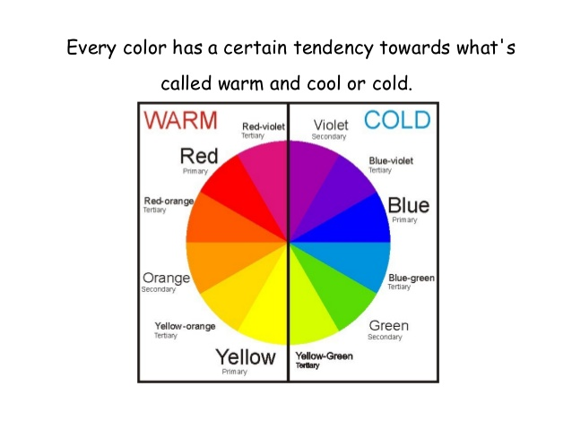

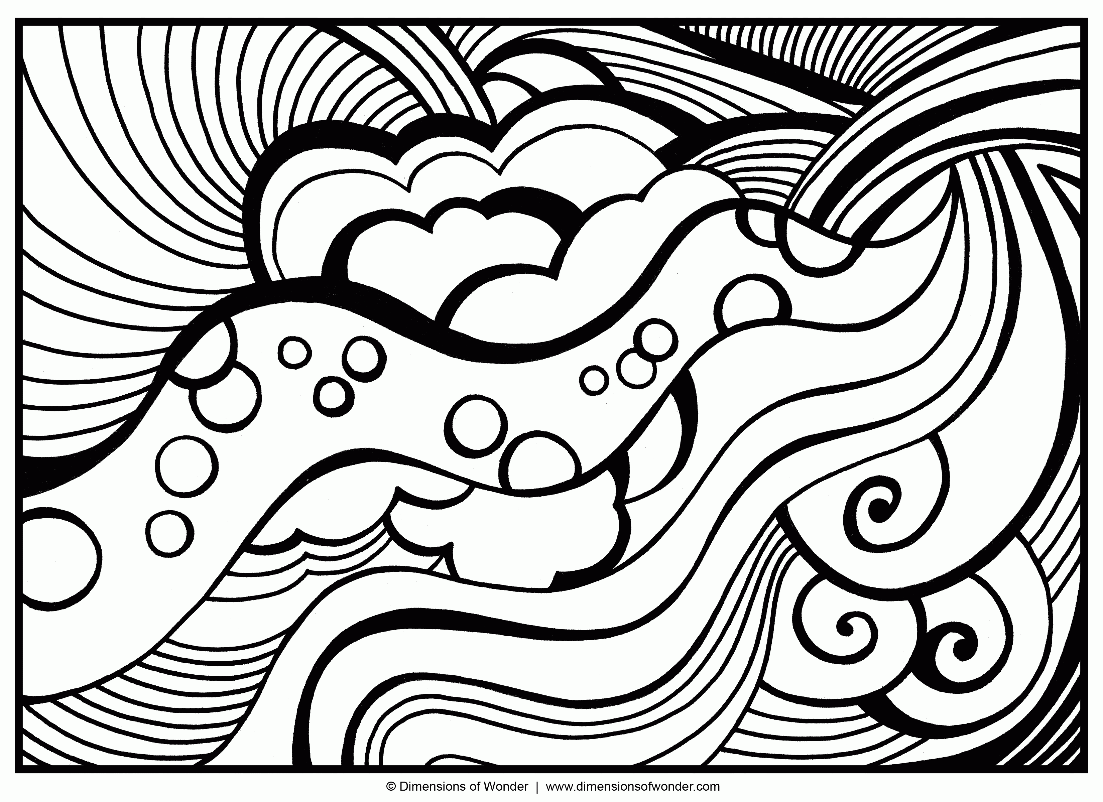
RESEARCH IS LEARNING ABOUT AN ARTIST ABOUT THE TIME AND PLACE WHERE THEY LIVED.WE FIND OUT AND WHAT INSPIRED THE ARTIST TO PRODUCE A PARTICULAR TYPE OR STYLE OF WORK.
CHOOSE AN ARTIST THAT YOU LIKE. FIND OUT ALL YOU CANAND MAKE SIMPLE NOTES, ADD IMAGES OF THEIR WORKINCLUDE TITLE AND DATES FOR WORK. PRESENT YOUR WORK INAN INTERESTING WAY.
