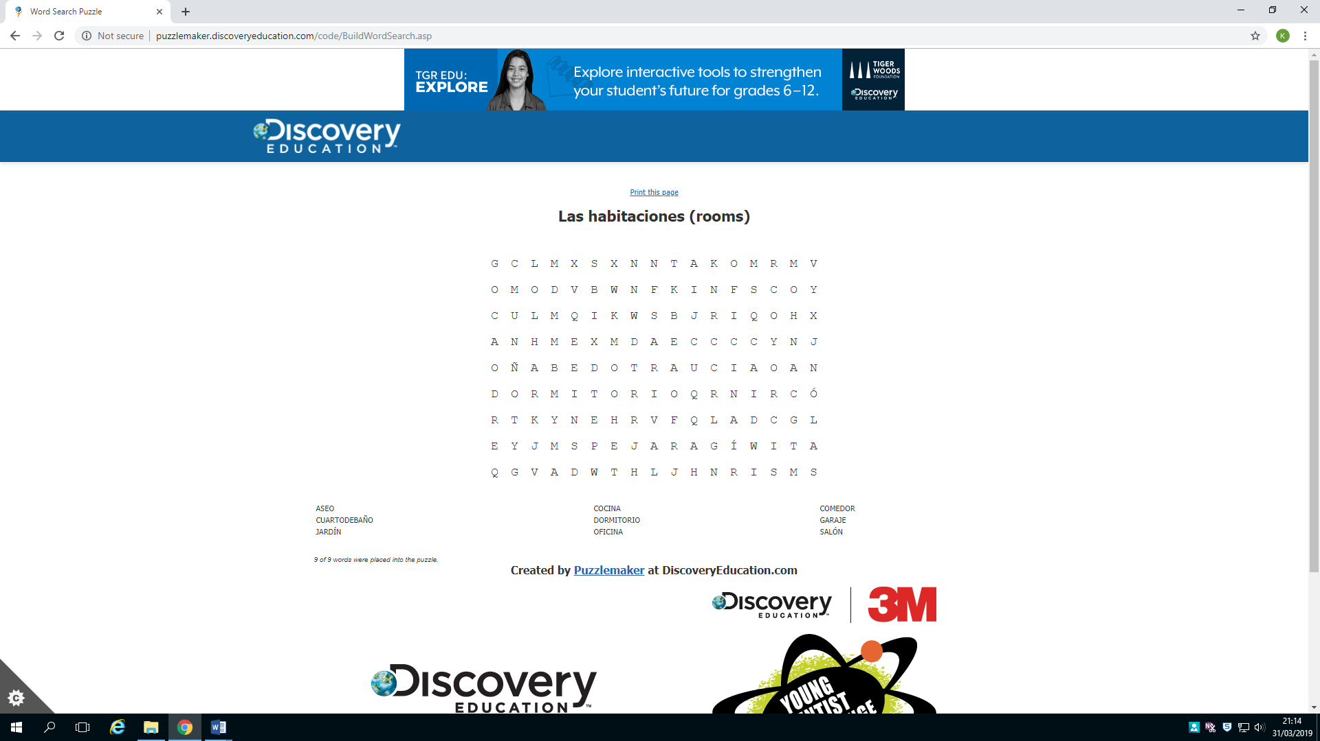**En casa– puzzles**

Write the Spanish for the following, and find them in the grid.

* Bedroom =
* Living room =
* Kitchen =
* Dining room =
* Bathroom =
* Toilet =
* Office =
* Garage =
* Garden =

**Los muebles (furniture)**

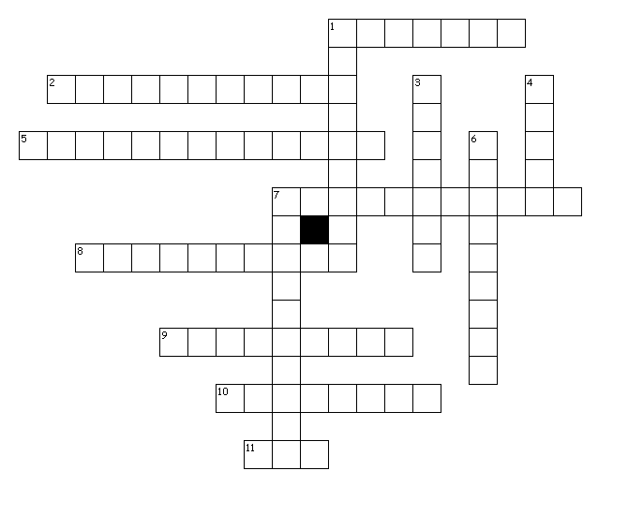

**Across**

1. a bed

2. a rug

5. a TV

7. a computer

8. a window

9. a wardrobe

10. a chair

11. there is

**Down:**

1. a chest of drawers

3. a table

4. I have

6. a door

7. a lamp

**Adjectives anagrams puzzle (then find the hidden phrase)**

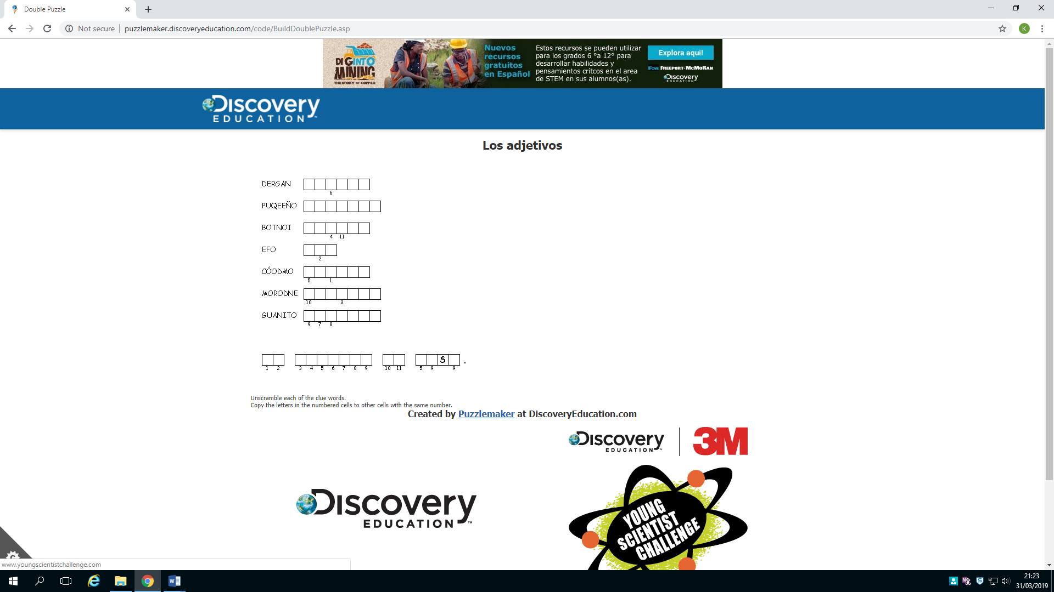

1 = big

2 = small

3 = pretty

4 = ugly

5 = comfortable

6 = modern

7 = old