TASK: Use the diagram below to describe how blood moves around the body.

BLOOD FLOW AROUND THE BODY
2.___________________________________________________________________
______
1.__________________________________________________________________________________________________
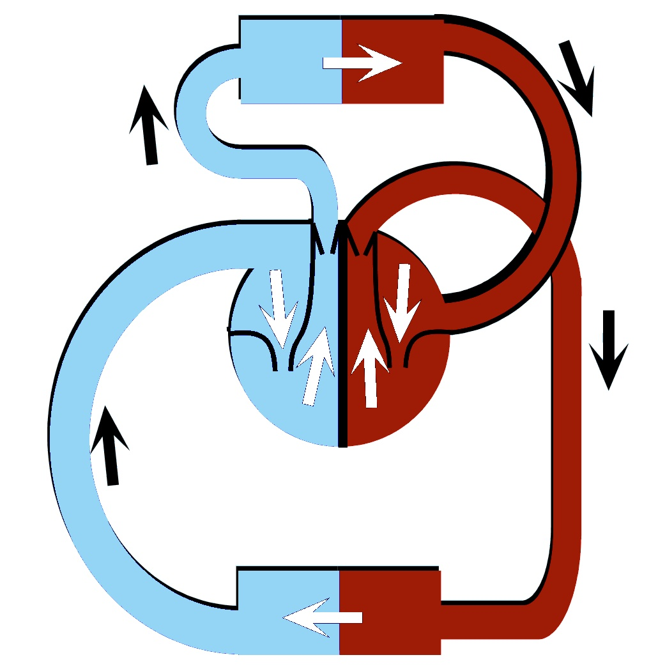
4._________________________________________________________________________________________________________________
_______
__________
3.__________________________________________________________________________________________________
____________________
ARTERY
_______________________
VEIN
Oxygenated Blood =
Deoxygenated Blood =
______
______

