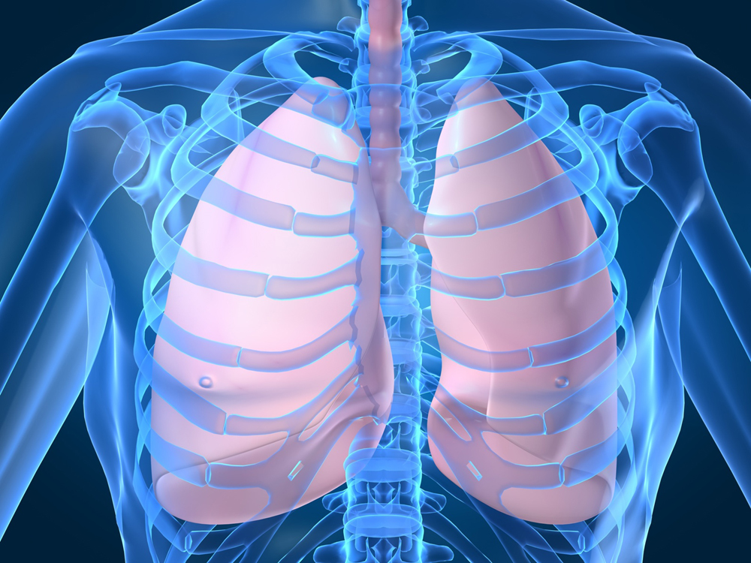

Diffusion

C:\Documents and Settings\tanyaa.STAFF.001\Local Settings\Temporary Internet Files\Content.IE5\4AMNVCUB\MCHM00247_0000[1].wmf

Artery

Capillary

Arteriole

Aorta

Gaseous Exchange

Vena Cava

Veniole

Vein

Left Ventricle

Left Atrium

Right Ventricle

Right Atrium

Pulmonary Artery

De-oxygenated

Oxygenated

Systemic Circulation

Pulmonary Circulation

Pulmonary Vein