|  |  |  |  |  |  |  |
| --- | --- | --- | --- | --- | --- | --- |
| **Year Group** | **Autumn 1** | **Autumn 2** | **Spring 1** | **Spring 2** | **Summer 1** | **Summer 2** |
| **Reception**  RWI | Children in Years R, 1 & 2 are following the RWI scheme for phonics input and reading development in smaller groups. The objectives and levels the children are working at change on a regular basis and can be better tracked through regular assessment updates. For more information please reference your child’s colour grouping in the provided Ruth Miskin Training Expectations of Progress document (Appendix 1a&b). | | | | | |
| **1**  RWI |
| **2**  RWI  &  Headstart | Goldilocks and the Three Bears  Little Red Riding Hood  Dinosaurs  The Great Fire of London  Mr Nobody  Miss Lucy Had a Baby | | Tug of War  The Monkey & The Crocodile  The Wise Boar  Looking After Pets  Town Mouse and Country Mouse | | Little Red, The Wold and the Three Bears  Country Mouse Goes to Town  My Body  Castles  School Sports Day | |
| **3**  Bug Club | While I am Sleeping  Hot Spots  King Kafu and the Moon | | Volcano Alert  When You Were My Age  Can You Change The World? | | The Fountain Of Gold  The Snow Queen  Escape From Black Mountain | |
| **4**  Bug Club | Mary Anning: The Girl Who Cracked Open The World.  Death of the Dinosaur  The Song of Sky and Sand | | Daring Deeds  The Mystery of the Red Moon  Hummingbird  The Race to the Pole  Leaving Home  Pigeons Rule the Roost!  Nanuck’s Tale  The Secret in the Attic | | Sean and the Sea Maiden  Odysseus and the Minotaur  A Tale of Two Poggles | |
| **5**  Bug Club | Under My Feet  The King in the Car Park  Below Deck: A Titanic Story | | Incredible Quests  The Hidden Heart of Me  The Making of a City  Escape at Bedtime  Adrift in New York  Wild Animals Are Not Pets  Wind Runner and the Hunt  The Londorium Transportium | | Hidden Heroes  The Longest Night | |
| **6**  Bug Club | Oliver Twist  Road to Freedom | | Risks and Thrills  From a Railway Carriage  The Red Lady  Haiku Year  The Cake Catastrophe  Switched!  Pukka! | | Beyond the Horizon  The Tree  A Tsunami Unfolds | |

Appendix 1a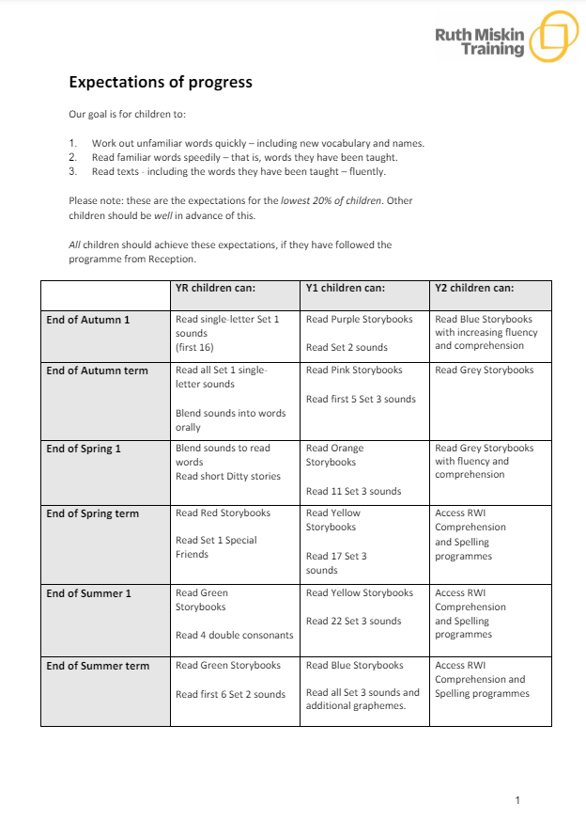

Appendix 1b

